Looking after your Mental Wealth

Mental wealth is an internal resource that is built from the following:
- What we think and how we talk to ourselves
- What information and ideas we feed our mind with
- What we do – meaningful work and hobbies that we get enjoyment from
- How we care for ourselves;
  - Sleep
  - Diet
  - Exercise
  - Relaxation
  - Lifestyle choices
- Accepting things as they are and being able to focus on what is good and what we have

Your ‘bucket’ of Mental Wealth
What do you do that builds up your mental wealth?

What do you do that drains your mental wealth?

Positivity

Energy

Resilience

Coping resources

5 ways to wellbeing cultivation and growing a
strong and full bucket of mental wealth could be:

Connect…
Connect with the people around you – family, friends, colleagues and neighbours. At home, work, school or in your local community. Think of these as the cornerstones of your life and invest time in developing them. Building these connections will support and enrich you.

Be Active…
Go for a walk or run. Step outside. Cycle. Play a game. Go into the Garden. Dance like no one is looking. Exercising makes you feel good. Most importantly, discover a physical activity you enjoy and one that suits your level of mobility and fitness.

Take Notice…
Be curious. Catch sight of the beautiful. Remark on the unusual. Notice the changing seasons. Savour the moment, whether you are walking to work, eating lunch or talking to friends. Be aware of the world around you and what you are feeling. Reflecting on your experiences will help you appreciate what matters to you. Stop and take a few minutes to take in your surroundings.

Keep Learning…
Try something new. Rediscover an old interest. Sign up for that course. Take on a different responsibility at work. Fix a bike. Learn to play an instrument or how to cook your favourite food. Set a challenge you’ll enjoy. Learning new things is fun and grows confidence.

Give…
Do something nice for a friend, or a stranger. Thank someone. Smile. Volunteer your time. Join a community group. Look out, as well as in. Seeing yourself and your happiness, linked to the wider community can be incredibly rewarding and creates connections with the people around you.

Mental Wealth

What sort of things could you start to do or do more of in each of the 5 categories?
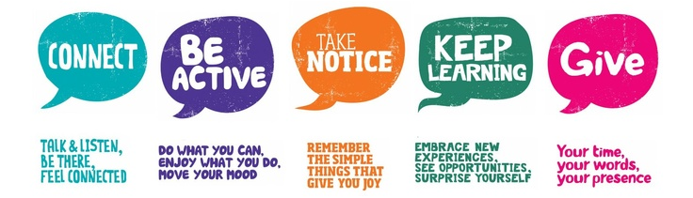

These evidence-based 5 behaviours are underpinned by cultivating a sense of meaning, purpose & direction, having things to look forward to, being positive, grateful and kind (to yourself as well as to others) and being at ease with yourself.
So, what will you do more of? less of? differently? new? to grow the size and strength of your mental wealth bucket.

Most of all…BE HAPPY!
Taken from: www.southampton.gov.uk/wellbeingatwork

